**OUTPUT:**

|  |  |
| --- | --- |
|  |  |
|  |  |
|  |  |

**DATA IN MS ACCESS:**

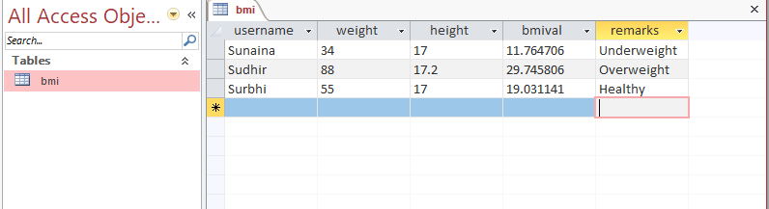

**IF REDUNDANT USERNAME IS ENTERED:**

|  |  |
| --- | --- |
|  |  |